LAB REPORT实验报告
Lab Title | Sorting |  |  |  | Lab No.
Stud. Name | 蒋云翔 | Major | CST |  | Class
Student ID | 2022102330 |  | Date | 11/13/2023
Lab description/objectives:
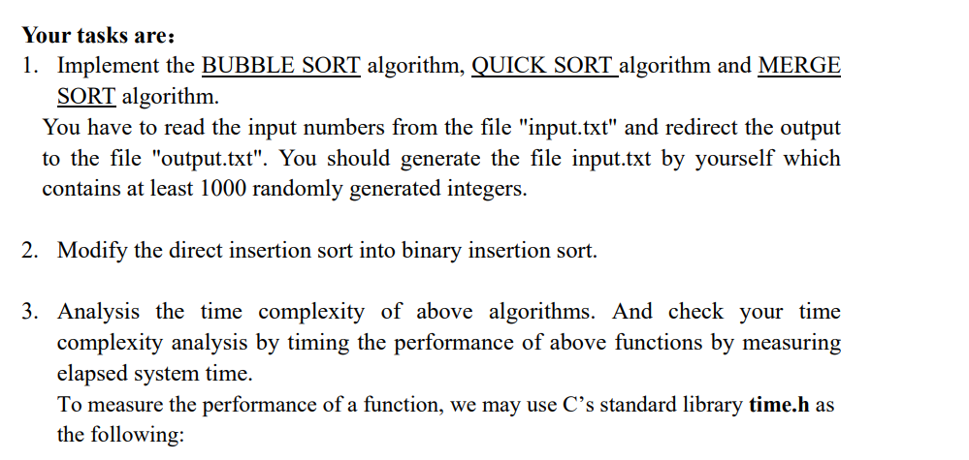
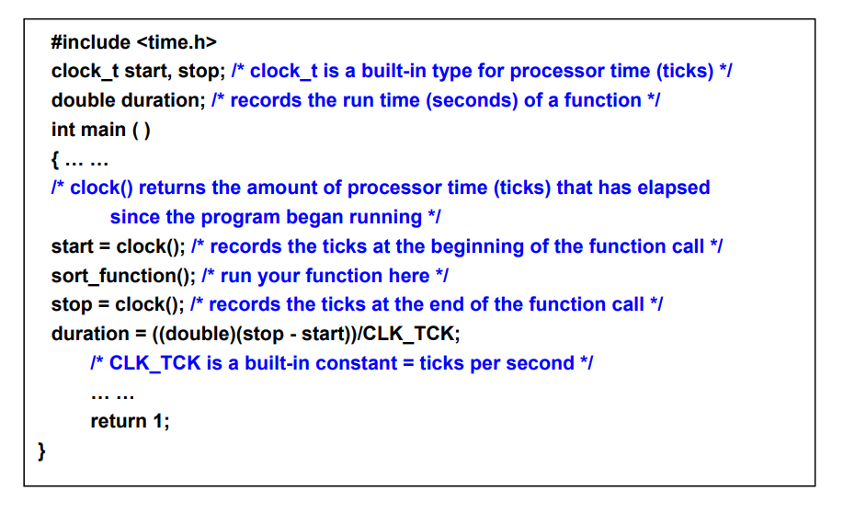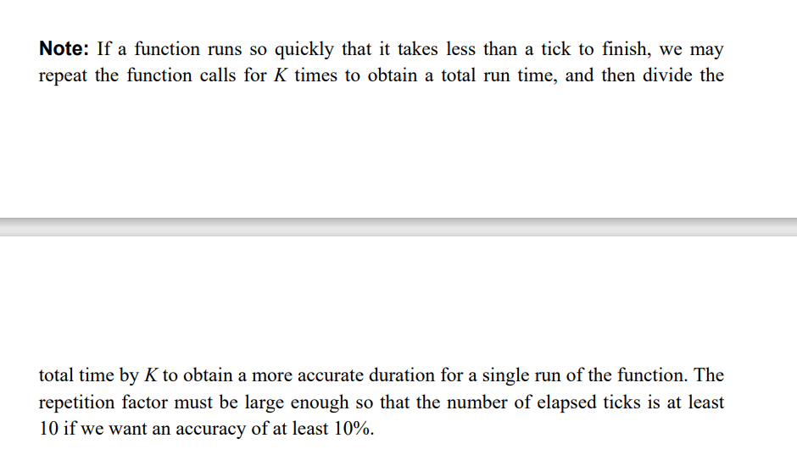
#include <stdio.h>
#include <stdlib.h>
#include<time.h>

void BubbleSort(int arr[], int length) {
for (int i = 0; i < length - 1; i++) {
for (int j = 0; j < length - i - 1; j++) {
if (arr[j] > arr[j+1]){
int temp = arr[j];
arr[j] = arr[j + 1];
arr[j + 1] = temp;
}
}
}
}

void QuickSort(int arr[], int start, int end) {
if (start < end) {
int pivot = arr[end];
int i = (start - 1); //设置辅助指针来进行数组元素交换操作
for (int j = start; j < end; j++) {
if (arr[j] < pivot) {
i++;
// exchange arr[i] and arr[j]
int temp = arr[i];
arr[i] = arr[j];
arr[j] = temp;
}
}
// exchange arr[i+1] and arr[end]，完成划分 [Reason:a[0]到a[i]都是小于pivot的值]
int temp = arr[i + 1];
arr[i + 1] = arr[end];
arr[end] = temp;
// 递归地对左右两部分进行快速排序
QuickSort(arr, start, i);
QuickSort(arr, i + 2, end); //The reason for i+2 is that：i+1 is the value of pivot
}
}

void merge(int arr[], int temp[], int left, int middle, int right) { //merge the two part that have been sorted already
int i = left;
int j = middle + 1;
int k = 0;
while (i <= middle && j <= right) {
temp[k++] = arr[i] <= arr[j] ? arr[i++] : arr[j++];
}
while (i <= middle) {
temp[k++] = arr[i++];
}
while (j <= right) {
temp[k++] = arr[j++];
}
//Copy the data to the original array
for (i = 0; i < k; ++i) {
arr[left + i] = temp[i];
}
}

// Mergesort
void MergeSort(int arr[], int temp[], int left, int right) {
if (left < right) {
int middle = (left+right) / 2;

// Using Mergesort to sort the left and right parts recursively
MergeSort(arr, temp, left, middle);
MergeSort(arr, temp, middle + 1, right);

// Merge the sorted sub array
merge(arr, temp, left, middle, right);
}
}

//Binary insertion sort
void binaryInsertionSort(int arr[], int length) {
for (int i = 1; i < length; i++) {
int selected = arr[i];
int first = 0;
int last = i - 1;

// Using binary search to find the correct position for the elements
while (first <= last) {
int mid = (first + last) / 2;
if (selected > arr[mid]) {
first = mid + 1;
}
else {
last = mid - 1;
}
}

// Move the elements
for (int j = i - 1; j >= first; j--) {
arr[j + 1] = arr[j];
}

// Insert the corresponding element to the very position
arr[first] = selected;
}
}

int main() {
clock_t start_bubble, start_quick, start_merge, start_binary, stop_bubble, stop_quick, stop_merge, stop_binary;
double duration_bubble = 0, duration_quick = 0, duration_merge = 0, duration_binary = 0;
// 生成随机整数的文件"input.txt"
FILE* file = fopen("input.txt", "w+");
for (int i = 0; i < 1000; i++) {
fprintf(file, "%d\n", rand() % 10000);
}
fclose(file);

// Read the datas from the file
file = fopen("input.txt", "r");
int numbers[1000];
int len = 0;
while (fscanf(file, "%d", &numbers[len]) != EOF) {
len++;
}
fclose(file);

int k = 100; // 重复排序的次数
// Using BubbleSort to sort the data
for (int i = 0; i < k; i++) {
file = fopen("input.txt", "r");
for (int j = 0; j < len; j++)
{
fscanf(file, "%d", &numbers[j]);
}
fclose(file);
start_bubble = clock();
BubbleSort(numbers, len);
stop_bubble = clock();
duration_bubble += ((double)(stop_bubble - start_bubble)) / CLK_TCK;
}

file = fopen("output_bubble.txt", "w+");
for (int i = 0; i < len; i++) {
fprintf(file, "%d\n", numbers[i]);
}
fclose(file);

// Using QuickSort to sort the data
for (int i = 0; i < k; i++) {
file = fopen("input.txt", "r");
for (int j = 0; j < len; j++)
{
fscanf(file, "%d", &numbers[j]);
}
fclose(file);
start_quick = clock();
QuickSort(numbers, 0, len - 1);
stop_quick = clock();
duration_quick += ((double)(stop_quick - start_quick)) / CLK_TCK;
}

file = fopen("output_quick.txt", "w+");
for (int i = 0; i < len; i++) {
fprintf(file, "%d\n", numbers[i]);
}
fclose(file);

// Using MergeSort to sort the data

for (int i = 0; i < k; i++) {
file = fopen("input.txt", "r");
for (int j = 0; j < len; j++)
{
fscanf(file, "%d", &numbers[j]);
}
fclose(file);
int* temp = malloc(len * sizeof(int));
start_merge = clock();
MergeSort(numbers, temp, 0, len - 1);
stop_merge = clock();
duration_merge += ((double)(stop_merge - start_merge)) / CLK_TCK;
}

file = fopen("output_merge.txt", "w+");
for (int i = 0; i < len; i++) {
fprintf(file, "%d\n", numbers[i]);
}
fclose(file);

//Using BinaryInsertionSort
for (int i = 0; i < k; i++) {
file = fopen("input.txt", "r");
for (int j = 0; j < len; j++)
{
fscanf(file, "%d", &numbers[j]);
}
fclose(file);
start_binary = clock();
binaryInsertionSort(numbers, len);
stop_binary = clock();
duration_binary += ((double)(stop_binary - start_binary)) / CLK_TCK;
}

file = fopen("output_binary.txt", "w+");
for (int i = 0; i < len; i++) {
fprintf(file, "%d\n", numbers[i]);
}
fclose(file);

duration_bubble = duration_bubble / k;
duration_quick = duration_quick / k;
duration_merge = duration_merge / k;
duration_binary = duration_binary / k;

printf("Time used of binary for 1 time with 1000 elements:%f\n", duration_binary);
printf("Time used of bubble for 1 time with 1000 elements:%f\n", duration_bubble);
printf("Time used of quick for 1 time with 1000 elements:%f\n", duration_quick);
printf("Time used of merge for 1 time with 1000 elements:%f\n", duration_merge);

return 0;
}
Program outputs:
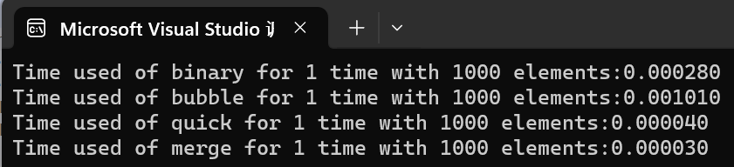
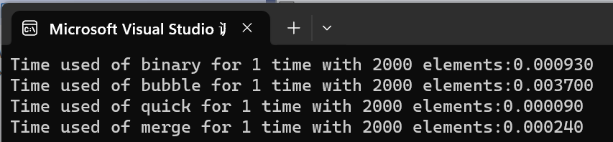
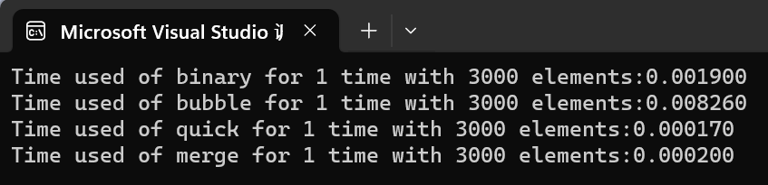
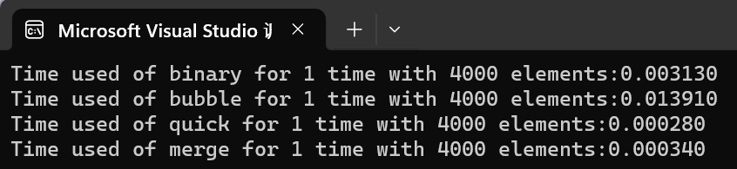
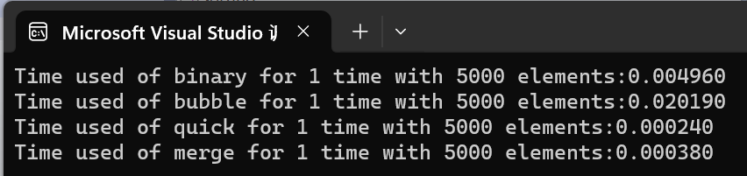
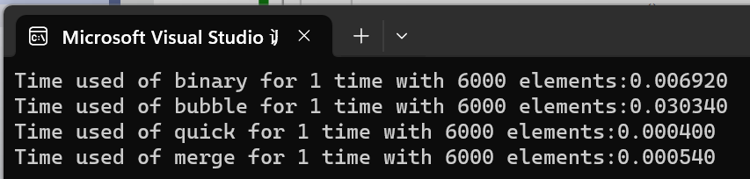
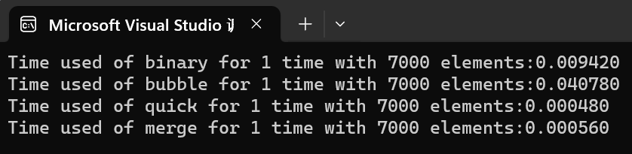
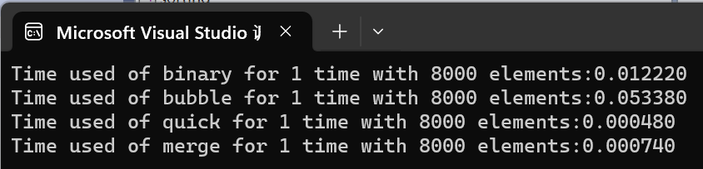
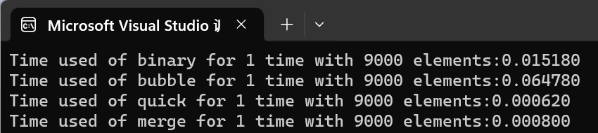
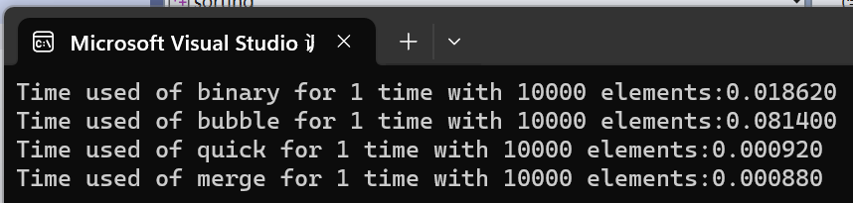
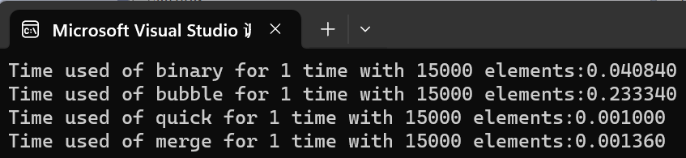
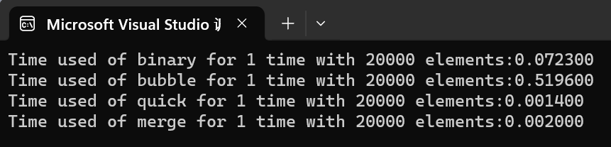
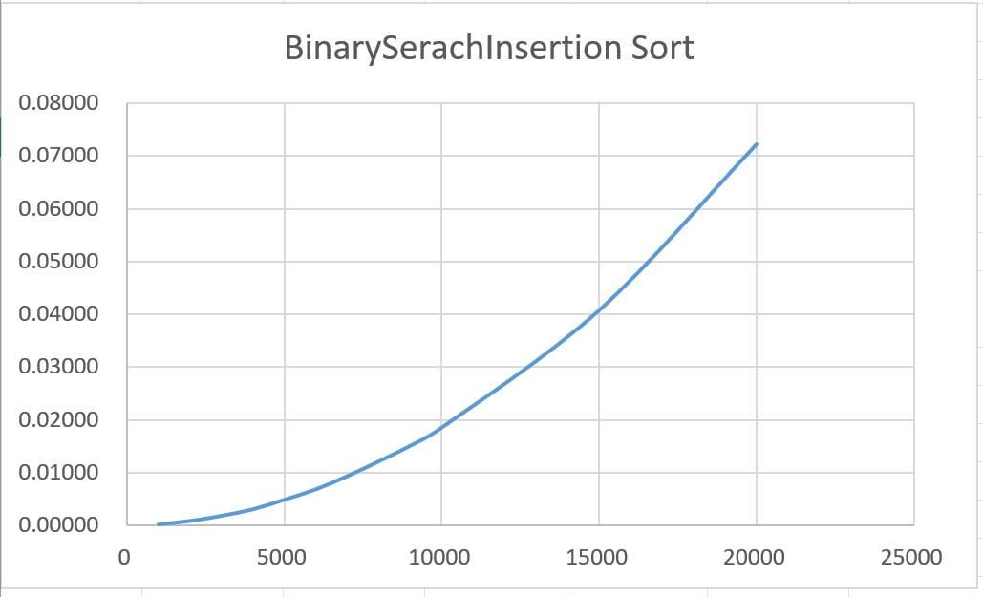

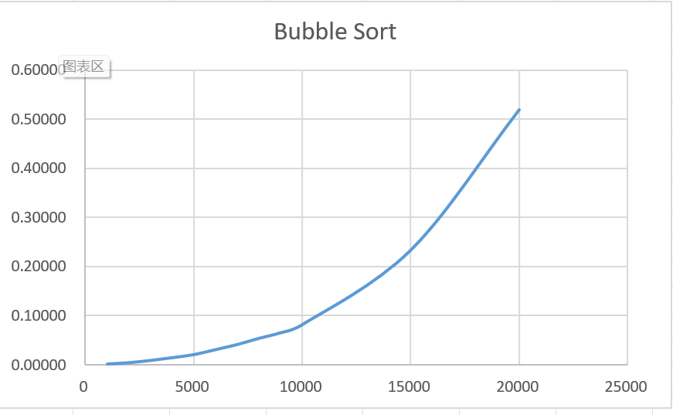
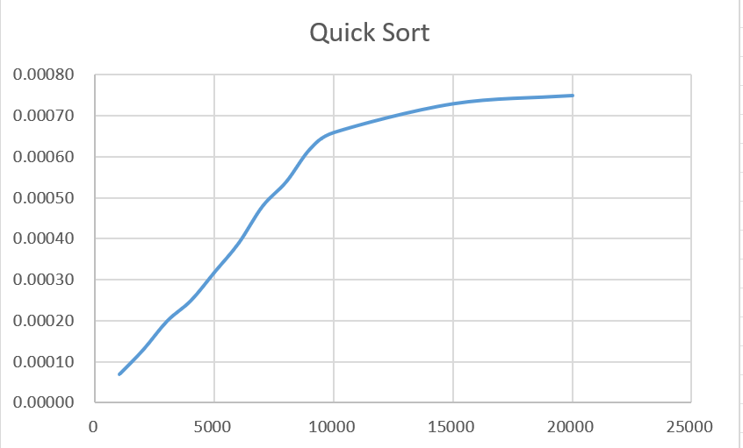

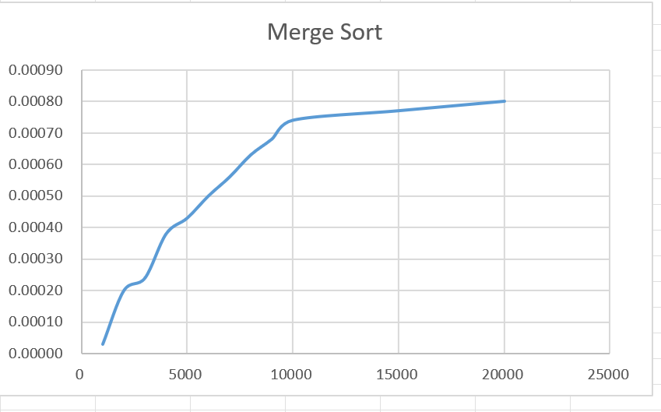

Analysis and Comments：
- Time complexity of each sorting method
Bubble Sort: The best, average, and worst case time complexity is O(n^2).
Quick Sort: The time complexity is O(nlogn) in the best and average case and O(n^2) in the worst case.
Merge Sort: The best, average, and worst case time complexity is O(nlogn).
BinarySearchSort: Its time complexity is O(n^2)

